1. 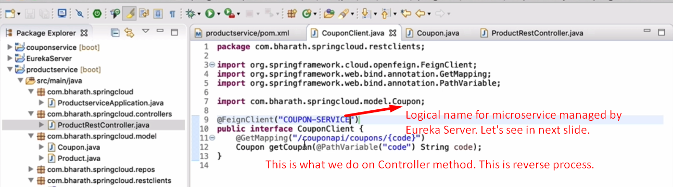
2. 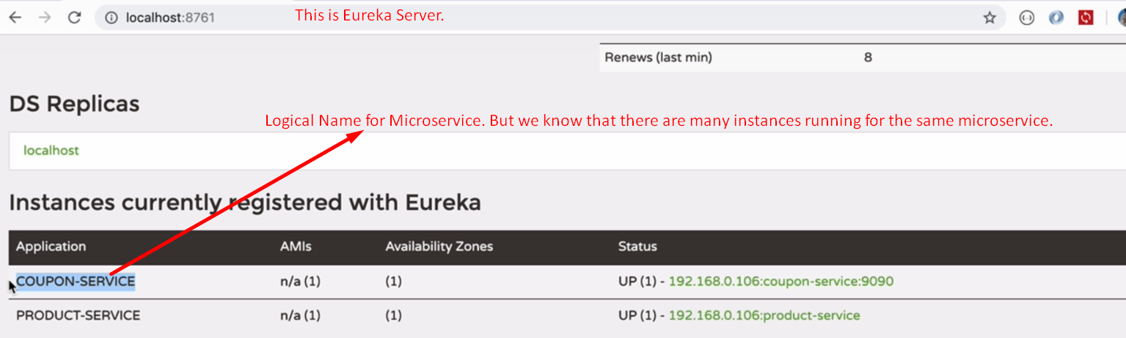
3. FeignClient internally uses Eureka Server to fetch the URLs.